SPH4U0 Graphical Analysis Example

- Plot a graph of Distance versus Time for a ball dropped from rest. (Traditionally, we describe a graph as “y versus x” so Distance goes on the y axis and Time goes on the x-axis. )
Time (s) | Distance (m)
0.00 | 0.00
0.20 | 0.20
0.40 | 0.78
0.60 | 1.76
0.80 | 3.14
1.00 | 4.90
1.20 | 7.06
1.40 | 9.60
1.60 | 12.54
1.80 | 15.88
2.00 | 19.60

- Identify the general type of relationship that is demonstrated between distance and time. ______________________________ (eg. Linear, power, root, etc.)

- Modify the independent values (the “x” variable data or time values in this case) to reflect the relationship identified and re-plot the data on a new graph. For example, if you think it is a root relationship, take the square root of the time (independent) variable and plot d versus $\sqrt{t}$.
- If the graph has been linearized and the y-intercept is close to the graph origin, find the slope of the graph. You can now express the full, mathematical relationship for the graph including a constant of proportionality.

Graphs:
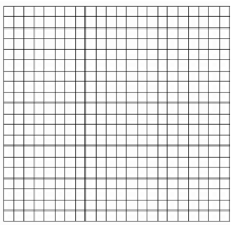

SPH4U0 Extra Practice: Using Graphical Analysis to find the Relationship between Variables
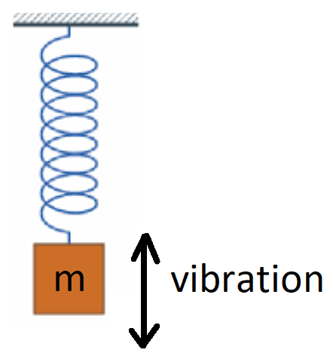
If a mass is suspended from a vertically mounted spring, it can be made to undergo vertical oscillations by pulling the mass down and releasing it from a stretched position.
Once released, the mass will vibrate up and down with a period of vibration, T, and a frequency of vibration, f. The frequency of vibration depends upon the stiffness of the spring (called the Hooke’s Law Constant) and the suspended mass. If you keep the spring the same, but increase the mass, you will find that the frequency decreases in a non-linear manner with the mass.
Determine the quantitative relationship between mass and the frequency of vibration from the given set of data.
HINT: The graphical analysis process will require THREE graphs in total!
Plot a graph of Frequency (on the y-axis) versus Mass (on the x-axis) and determine how frequency depends upon mass.
Mass, M  (kg) | Frequency, f  (Hz)
0.10 | 3.56
0.20 | 2.52
0.30 | 2.05
0.40 | 1.78
0.50 | 1.59
0.60 | 1.45
0.70 | 1.34
0.80 | 1.26
0.90 | 1.19
1.00 | 1.13

(Ans: f= 1.125 $\frac{\sqrt{kg}}{s}$ •$\frac{ 1}{\sqrt{M}}$)

